EXPERIMENT NO: 13

Determination and plotting of intinsic impedance and phase velocity of various medium
Aim:
To determine and plot intrinsic impedance and phase velocity of various medium.

Software required:
- SCILAB version 6.0.1

Program:

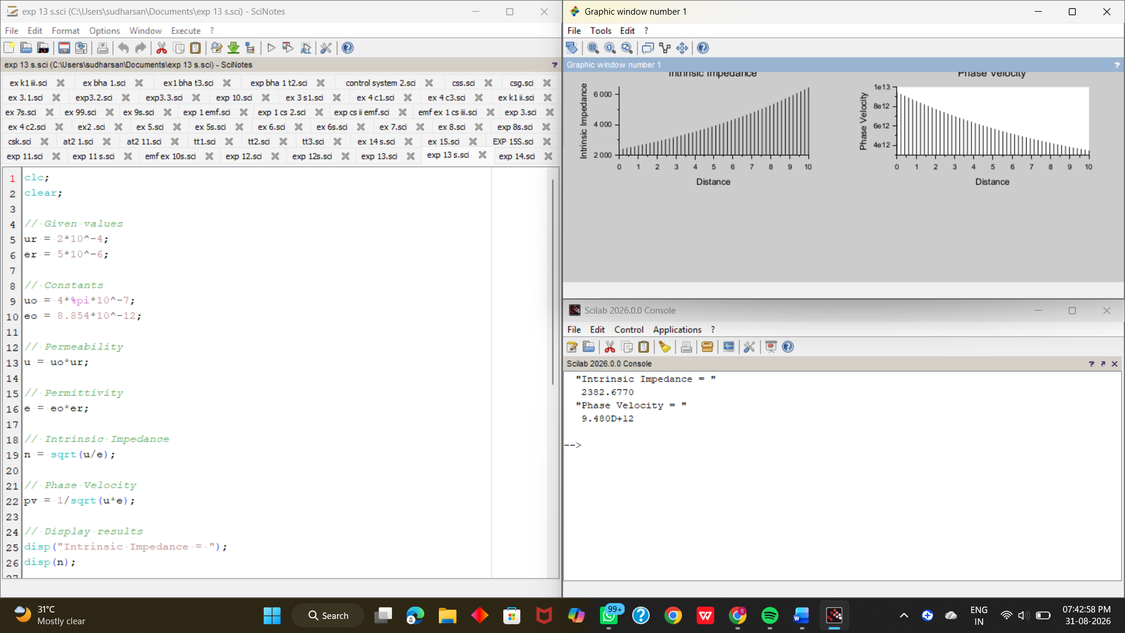

Output:



Theoretical calculation:

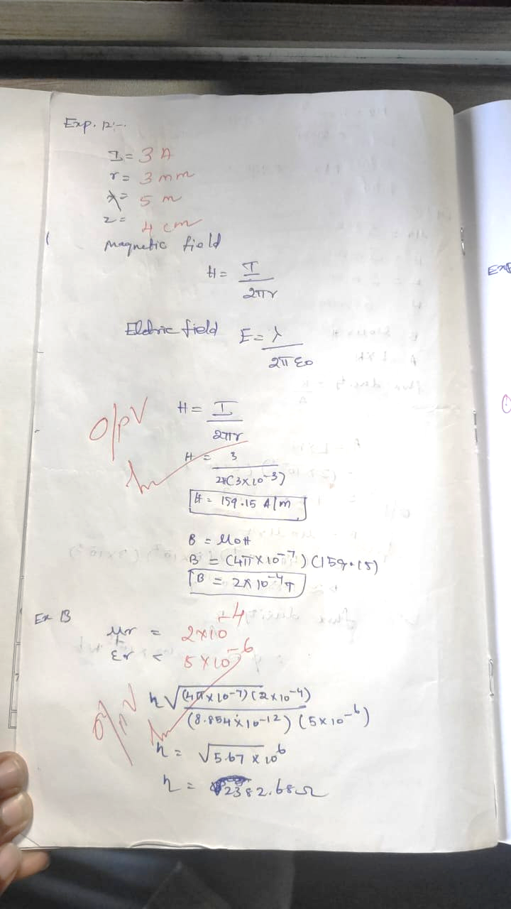

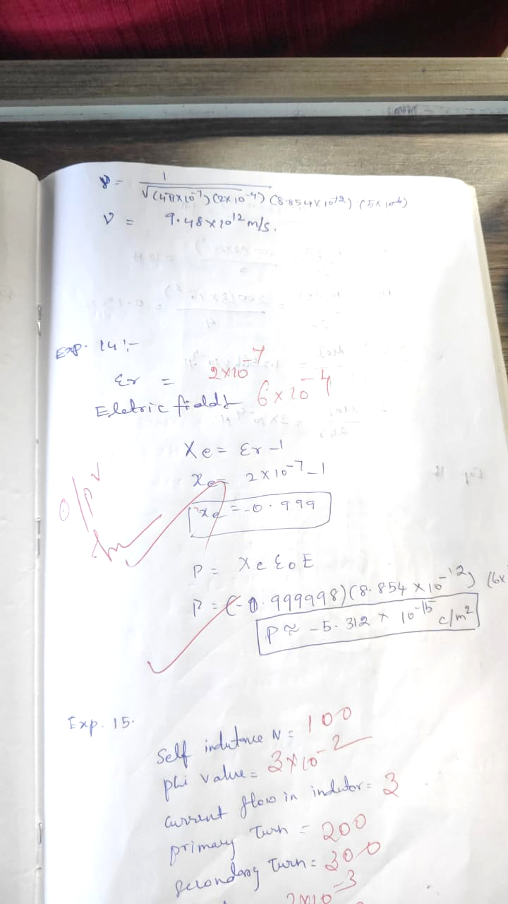
Case 1: To determine the intrinsic impedance and phase velocity of electromagnetic waves in free space(vacuum).

Program:
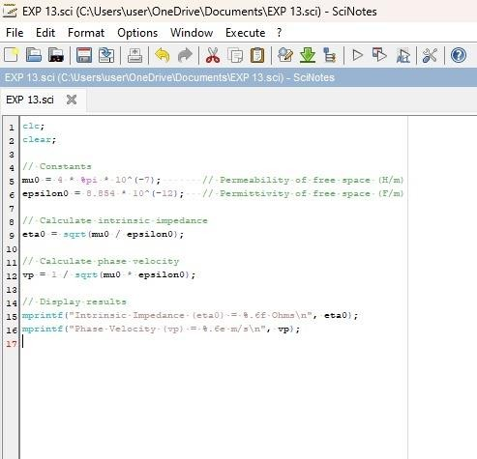

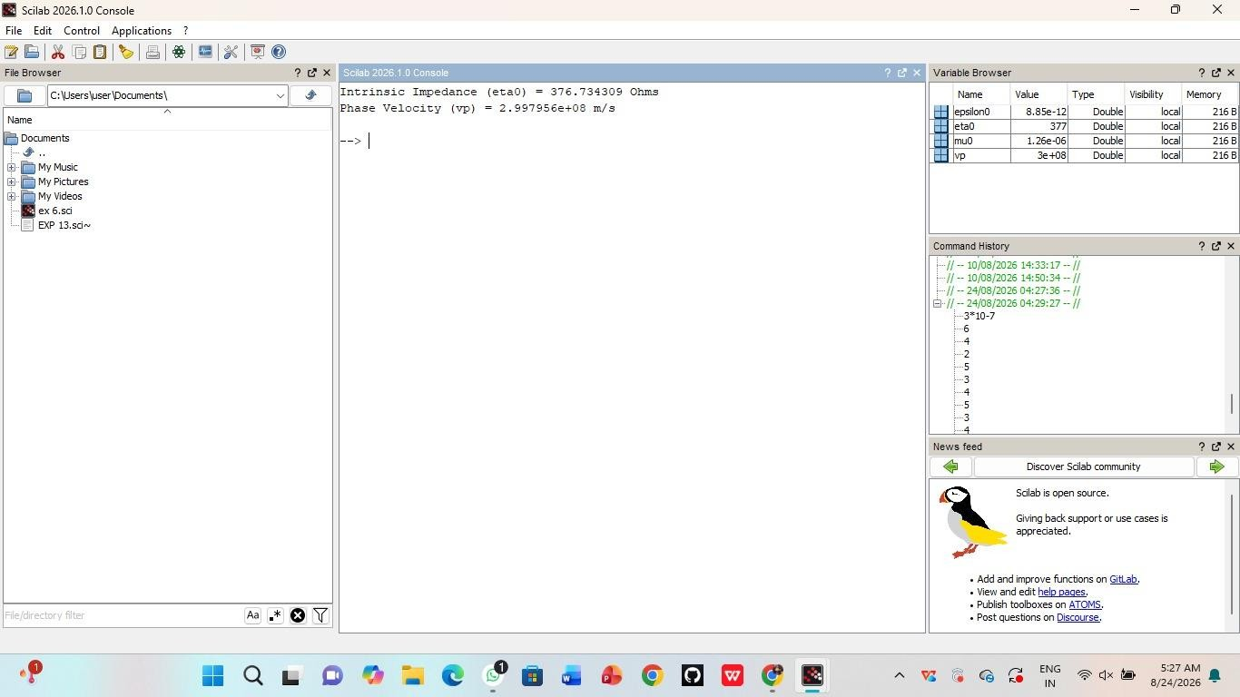
Output :
Case 2: To determine the intrinsic impedance and phase velocity for a wave propagating through a conductive medium like copper.

Program:
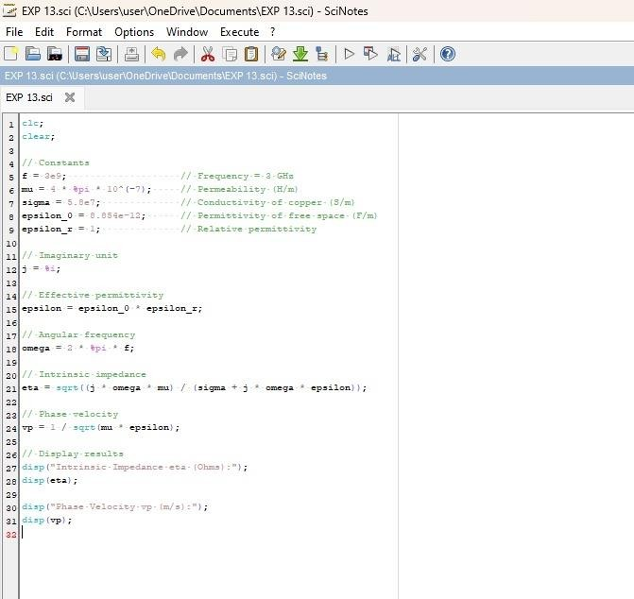

Output :
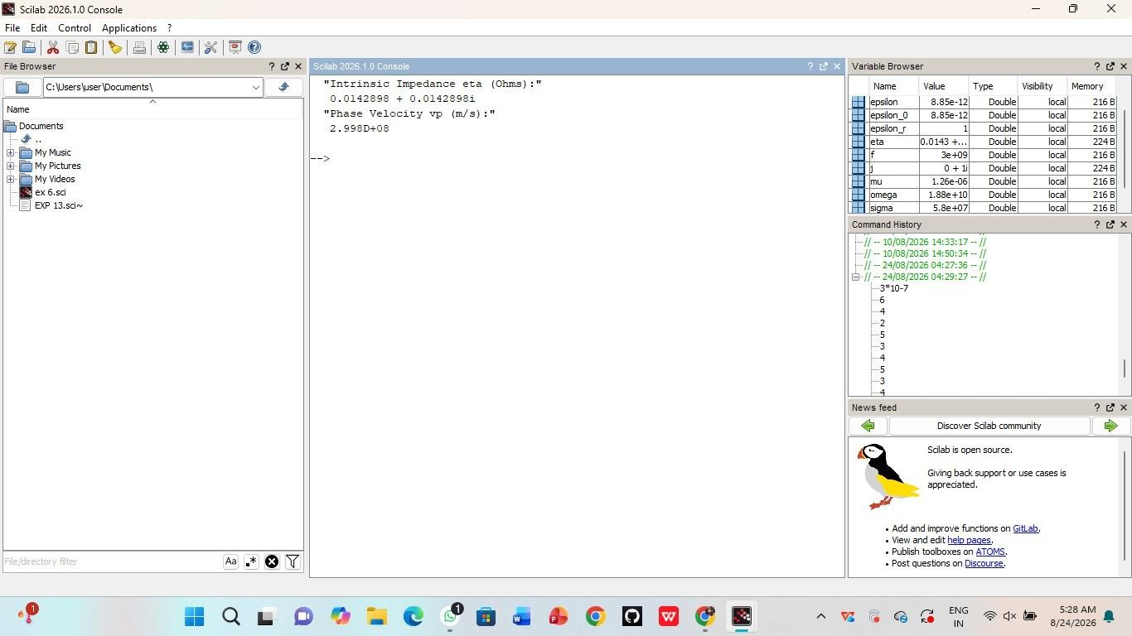
Case 3: To determine and compare the intrinsic impedance and phase velocity of electromagnetic waves propagating through different media: Vacuum, Air, and Water.

Program:
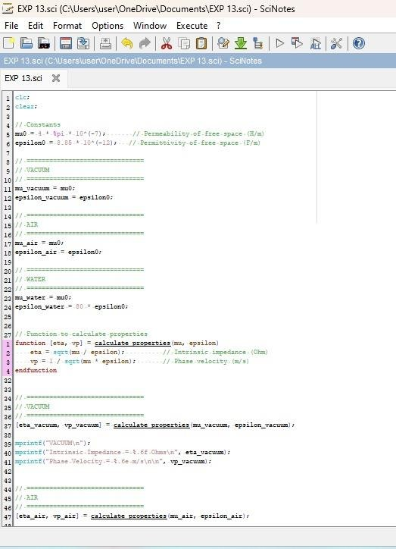
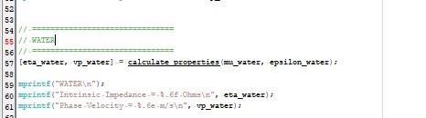

Output:

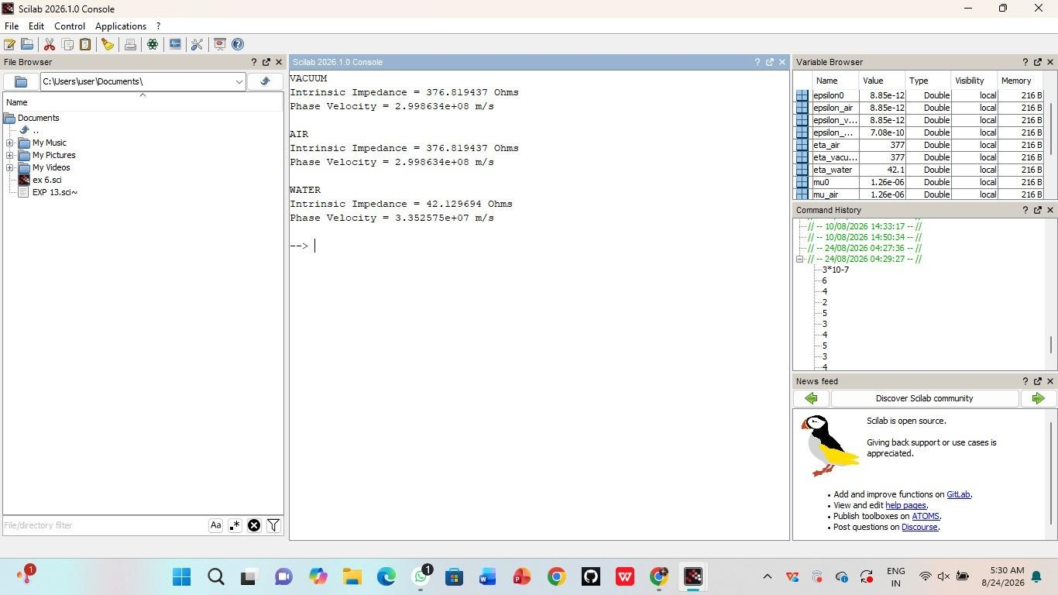

Result:
Thus the determination and plotting of intrinsic and phase velocity is performed and successfully verified in copper.

